CS4321 QUIZ 5 (Dec. 11)

NAME (5 points):

- (2 points) Fill the empty slots of the following dynamic programming table for calculating the longest common subsequence.
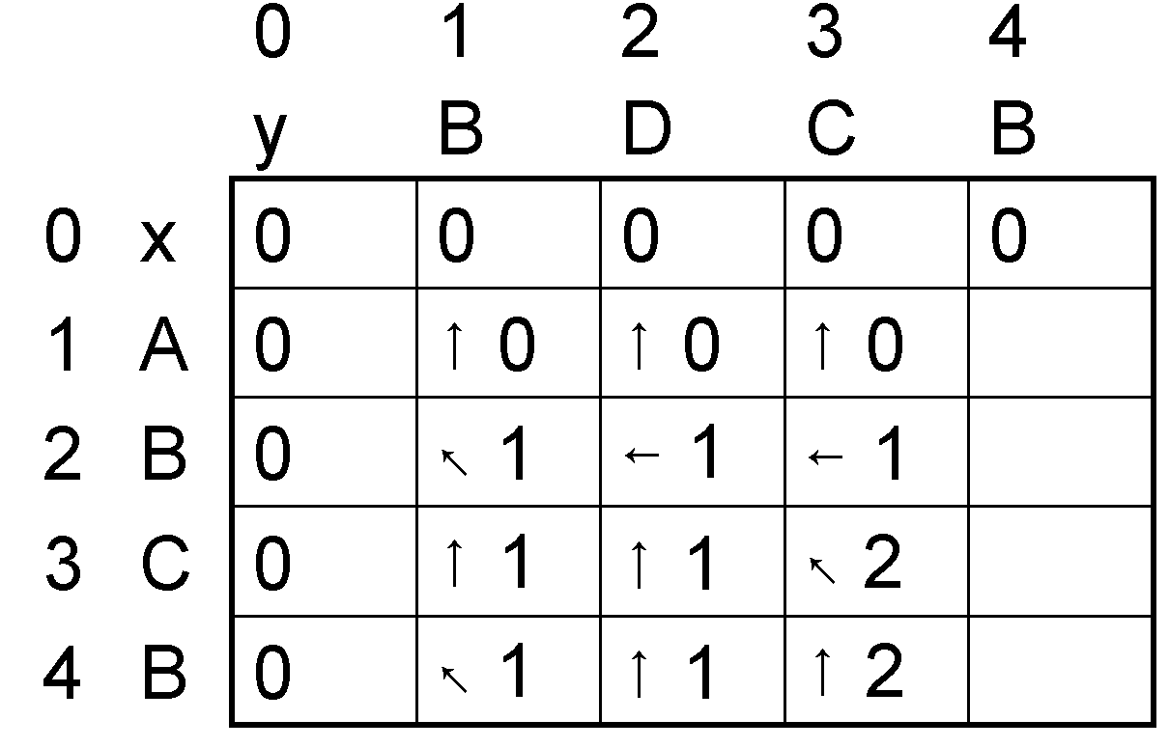

- (3points) We discussed depth-first search of a graph in class. We defined the discovery time as the time a node is first-time discovered and the finish time as the time it is finished. The following graph shows the discovery time (left) and finish time (right) of each node and the bold edges compose the search tree.

1
2
3
4
5
1
2
3
4
5
6
7
8
9
10

Apply depth-first search on the following graph using the node number as the tie-breaker (smaller node first).
  - (2 points) Show the discovery time and finish time of each node.
  - (1 point) Draw the search tree.

1
2
3
4
5
6

